TASK 14: Development of Embryo, Foetus, birth and infant Test (81 marks)
Students will complete a number of questions relating to reproduction. These questions will address specific content as well as analysis of second hand data. This task will be completed in one session under test conditions.

Time for the tasks (1 hour)
- 5 minutes reading time
- 55 minutes working time

What you need to do:

- Follow the instructions provided very carefully to complete the test.

- Draw any results in pencil and answer all questions given.

- It is your responsibility to organise your time effectively.

- There is to be no discussion between you or any of your class mates.

- No sharing of any equipment or answers at all.

SECTION | Question Type | Marks available | Your mark
A | Multiple Choice | 14
B | Short Answer | 39
C | Extended response. | 28
 |  | 81

DO NOT TURN THIS PAGE OVER UNTIL YOU ARE TOLD TO

STUDENT NAME: __________________________________________________________________

TEACHER: Mrs Cunningham YEAR: 11

PART A: Multiple choice questions.

Please mark your answers in the answer section provided and NOT on the questions.

1. The sex of a foetus can generally be determined after

- 8 weeks
- 16 weeks
- 24 weeks
- 30 weeks

2. The milk secreting regions of the human breast are called

- lobules
- lobes
- alveoli
- areola

3. The best advantage of breast feeding over bottle feeding is

- the milk does not need to be warmed
- breast milk contains antibodies which protect the child against disease
- breast milk does not contain too much fat
- breast milk does not cause colic

4. After what stage of pregnancy is the ‘baby’ called a foetus?

(a) conception
(b) 16 weeks
(c) 8 weeks
(d) 12 weeks

5. The mother’s first secretion from her breast just after the baby is born is called

- puerperium
- vernix
- colostrum
- mastitis

6. When a child is born what part of its body takes up the greatest proportion of it?

- legs
- arms
- trunk
- head

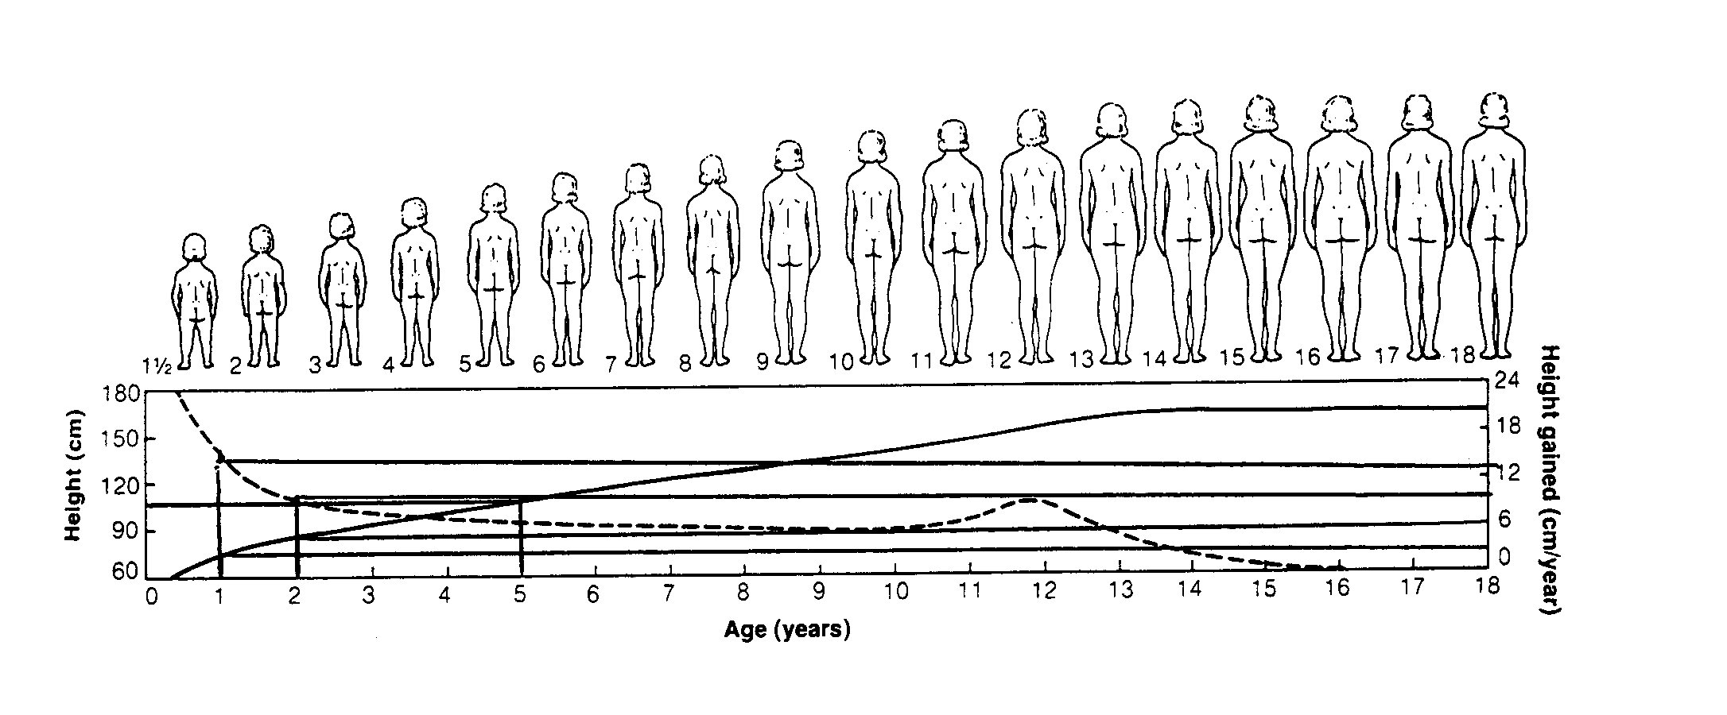
7. Using the table above the average height gained by a female between the ages of 1 year and 2 years of age is

- 3 cm
- 4 cm
- 5 cm
- 6 cm

8. According to the graph below, what percentage of the total brain weight is a baby born with?

(a) 27%
(b) 15%
(c) 47%
(d) 52%
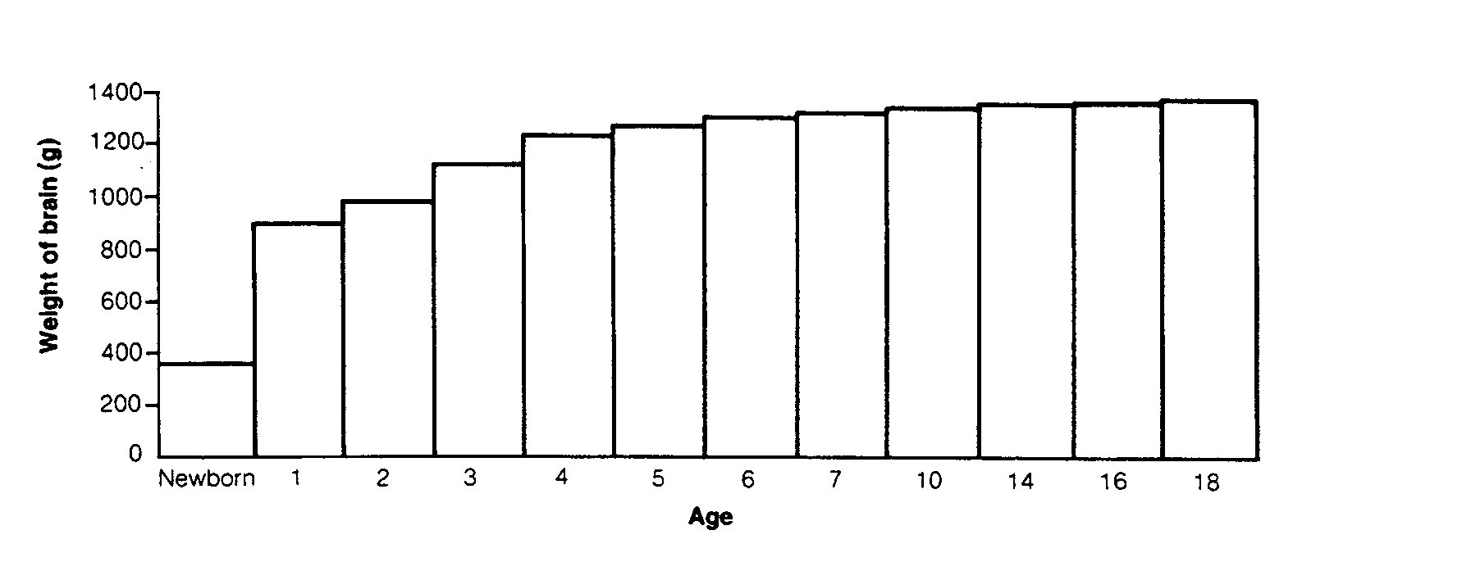

9. A zygote is the cell that results from the union of two

- gametes
- eggs
- chromosomes
- genes

10. The development into sexual maturity is termed

- adolescence
- growing pains
- puberty
- maturity

11. During the time that a foetus is developing inside the uterus

- it uses food that has been stored in the placenta
- it is nourished via the umbilical cord .
- it uses food stored in a yolk
- it is supplied with nutrients from the amniotic fluid

12. During which stage of labour is the baby actually born?

- first
- second
- third
- initial

13. The primary germ layer known as ectoderm gives rise to which of the following structures in the embryo

- nervous system and skin
- muscle and blood
- lining of the respiratory system
- lining of the kidneys

14. What is the function of the umbilical artery?

(a) Connect maternal blood to foetal blood.
(b) Carry deoxygenated, nutrient depleted blood from foetus to the placenta
(c) Carry oxygenated, nutrient rich blood from the placenta to the foetus
(d) Carry oxygenated, nutrient rich blood from the foetal heart to other body areas.

15. Which of the following cannot cross the placenta?

(a) Glucose
(b) Oxygen
(c) Red blood cells
(d) Rubella virus

END OF MULTIPLE CHOICE QUESTION SECTION

PART B: Short Answer questions. [39 marks]

Please write your answers in the spaces provided on this sheet.

1. Terminology – write the correct term for each definition below
No. | DEFINITION | TERM
1 | Innermost lining of the uterus | endometrium
2 | Organ in the uterus which sustains the foetus | placenta
3 | Normal duration of human gestation | 9 months/40 weeks/  pregnancy
4 | Membrane that encloses the foetus in a fluid filled sack | amnion
5 | Hormone which causes uterine contractions | oxytocin
6 | The germ layer which forms the muscles, connective tissue and lymphoid tissue | mesoderm
7 | Part of the blastocyst which develops into the embryo | Inner cell mass
8 | Uses inaudible, high frequency sound waves to produce an image of the foetus. | ulltrasound
9 | A man’s sperm being used to fertilise a woman’s egg in a glass dish. | In vitro fertilization/IV
10 | The placenta is attached to the foetus by this structure | Umbilical cord

[10 marks]
2. List three symptoms of early pregnancy.

- _____Morning sickness______________________________________________

- ___urgency to urinate_______________________________________________

- ____enlargement of breasts____________________________________

[3 marks]
3. Explain the extent to which the following are affected in a pregnant woman.
(a) Uterus increases in size until approx. 10x _______________________________________________________________________
______________________________________________________________________
(b) Heart increases in size (doubles) and increase in blood volume ______________________________________________________________________
______________________________________________________________________
[c] Bladder pressure is increased due to expanding uterus –creates a sensation of fullness ______________________________________________________________________
_______________________________________________________________________
- Breasts enlargement and at birth milk secretions.
______________________________________________________________________________________________________________________________________________
[4 marks]

4. State what happens in the three stages of labour;
Stage 1 ____________Dilation of cervix_______________________

Stage 2 _______________expulsion/birth____________________

Stage 3 ___________after birth________________________
[3 marks]

5. (a) List three substances which pass across the placenta FROM the mother to the baby.

1. ______oxygen 2. _____nutrients
3. ____antibodies
[3 marks]
(b) List two substances which pass across the placenta FROM the baby to the mother.

1. ______urea 2. _____ carbon dioxide
[2 marks]

6. Label the following diagram in the spaces provided below.
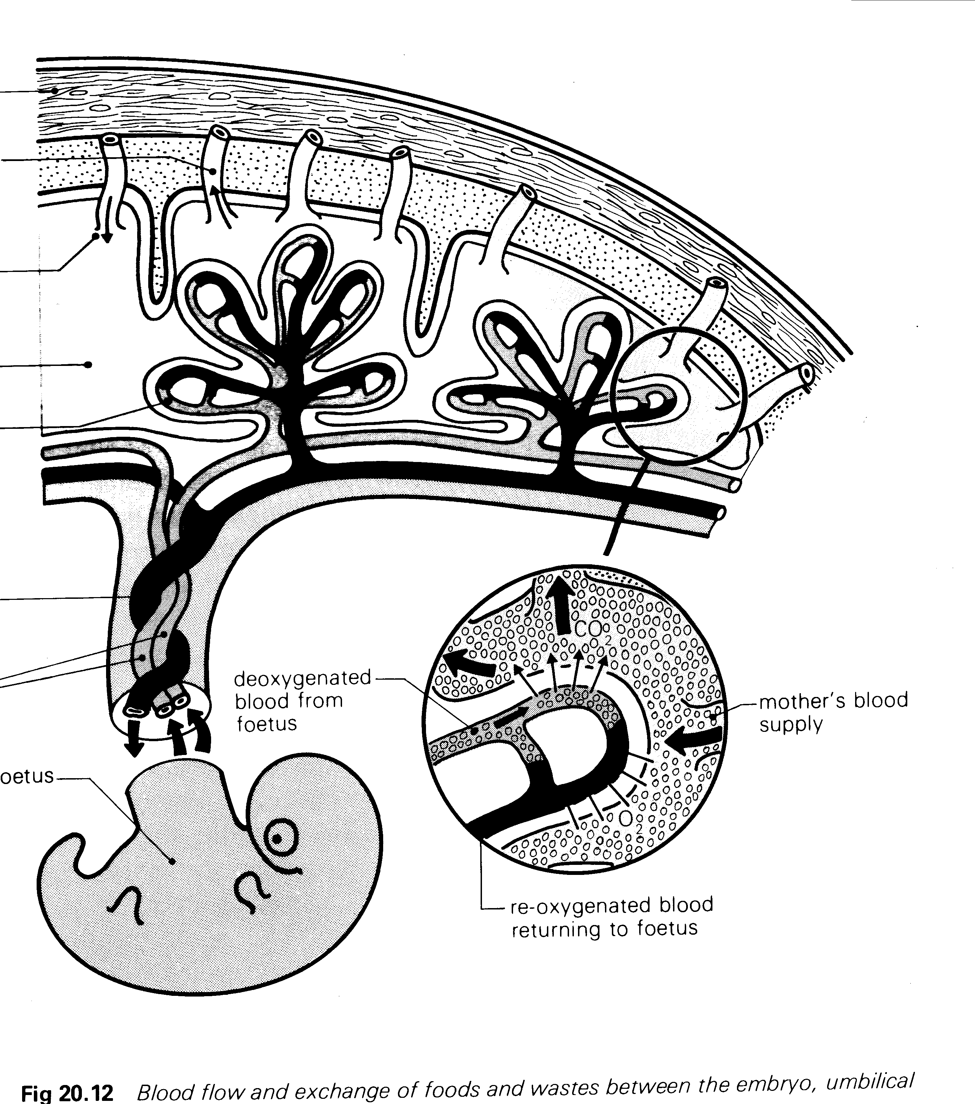
Uterine blood

vessel
Umbilical arteries
Umbilical veins
Deoxy blood from foetus
Blood space
Maternal blood
Uterine wall

[7 marks]

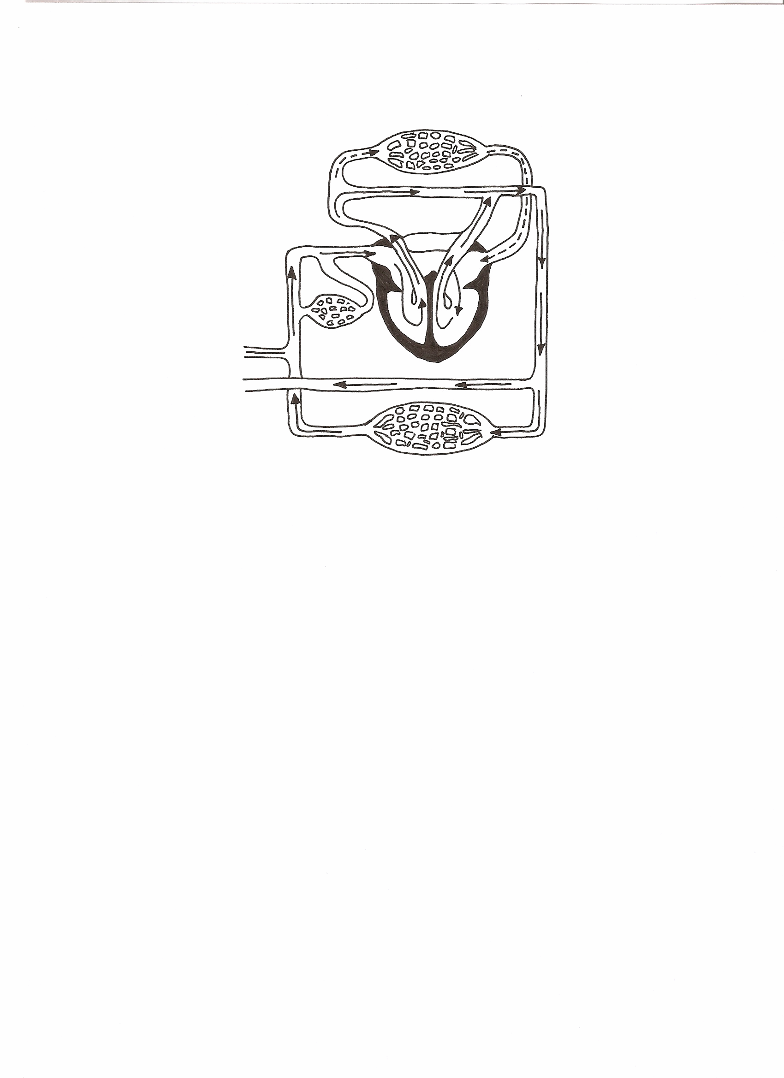
7. Label the following diagram of foetal circulation.
lungs

Foramen ovale

Ductus venosus
aorta

Umbilical veins

body
Umbilical arteries

[7 marks]

PART C: Extended Answer question [ 28 marks]
Pregnancy is a time of major changes to both mother and child. Once the baby is born, this time of change continues as both mother and baby adjust to the post pregnancy world.

1. In dot point form describe and explain the purpose of four physical or functional changes that happen to the baby in the period just after it is born.
Similarly, in dot point form, describe and explain 3 physical changes which happen to the mother in the approximately 8 weeks following giving birth

Basically the structural change and why it needs to happen – 2 marks each
e.g. Pulse often slower – blood volume was increased with foetus –goes slow with mother’s tissues getting enough blood supply – as volume of blood decreases pulse will return to normal
Baby – Changes after birth | Mother –changes in first ~ 8 weeks
- Circulation changes –plus one of the changes below * to give an example | No emotional stuff – just asked for physical changes
- Bypasses become non-functional – blood flow is ‘normal | - Contractions continue after birth – uterus reduces in size – back to normal
- Blood through ductus arteriosus decreases | - Abdomen flattens as muscles contract the uterus
- With more blood flowing through heart, BP increases | - Fluid discharges from uterus – after birth etc.
- Increased BP causes flap of foramen ovale to close – eventually permanently | - Blood volume returns to normal
- Umbilical cord is cut – blood no longer flows through umbilical blood vessels, nor the ductus venosa – liver bypass | - Pulse often slower
- Ductus venosus eventually closes – no blood going through – all blood goes through the liver | - Body temp a little above normal - increased rate of cellular respiration = heat – gradually/eventually lowers
- Reflexes – survival mode for the baby –sucking, grasping, swallowing, breathing | - Menstruation may begin again if not breast feeding
- Lungs, liver …become fully functional as blood flows through these organs | - Lactation –breasts larger due to milk production and storage
- Breathing commences – lungs functional
- Breathing rate and heart rate initially fast, gradually slows
.[14 marks]
.
2. There is a great range in the sizes and shapes of the female breast but they all function in a similar manner during lactation.
a. What does the term lactation refer to?
Initiation and maintenance of milk secretion [2 marks]
b. Label the following numbered parts from the diagram below: [4 marks]
3._______lobules
4._______nipple
5._______areola
6._______milk ducts/space
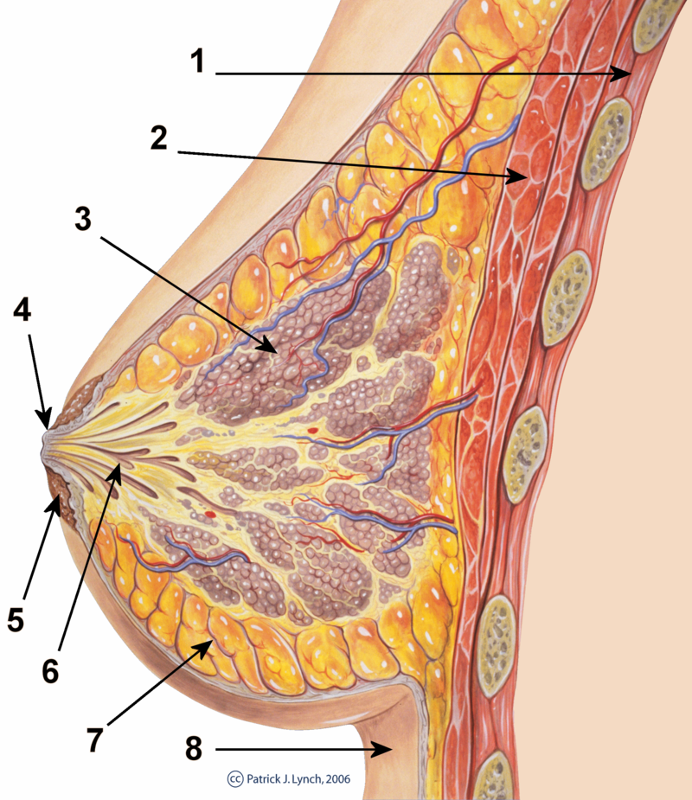

c. Explain how the structures of the human breast numbered 3, 4, and 6 above, are related to the process of lactation. Also include a description of the initial discharge from the breast, and how it differs from later milk produced by the mother.
[8 marks]
- Colostrum initial discharge from breast: 1 3 points
- watery, yellowish; no or little fat; 1
- high content of mother’s antibodies –absorbed through baby’s intestines 1

3 – lobules 4 – nipple 6 – milk ducts/milk spaces

5 points

- Alveoli – glands on wall of lobules – secretes milk 1
- Milk moves from lobules, through milk duct, to milk space 1
- Milk spaces store milk 1
- When nipples are suckled, let-down reflex is triggered 1
- Hormonal control – release of oxytocin causes tiny muscles to contract the lobules 1
- Milk is ejected into the ducts 1
- baby continues to suck on nipple, sucks the milk into their mouth 1 – happy baby.

